Coming Auctions at Burchard Galleries
Saturday February 18th, 2023 12 PM
500+ Lot Estate Antiques Fine Art & Jewelry Auction
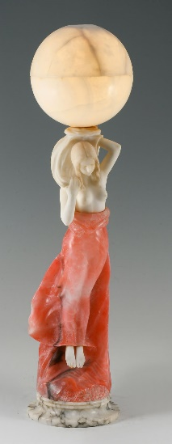
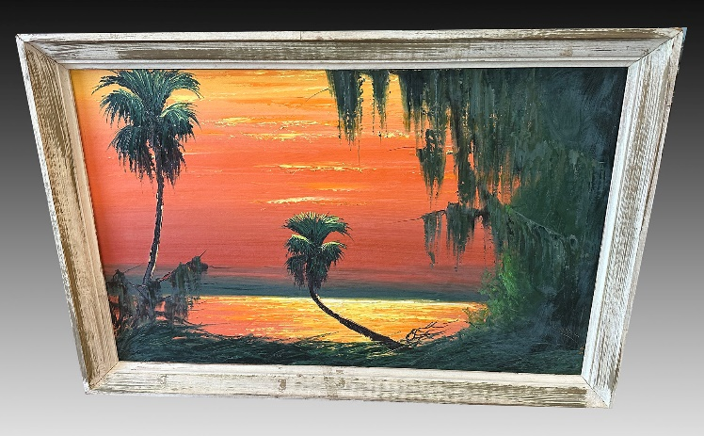
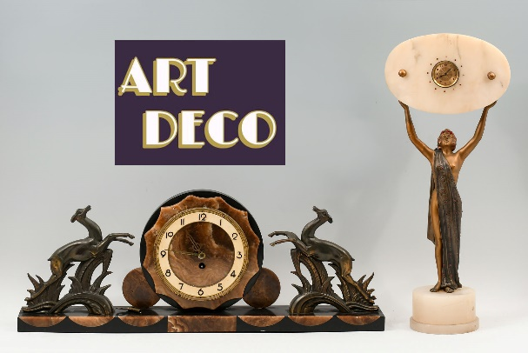
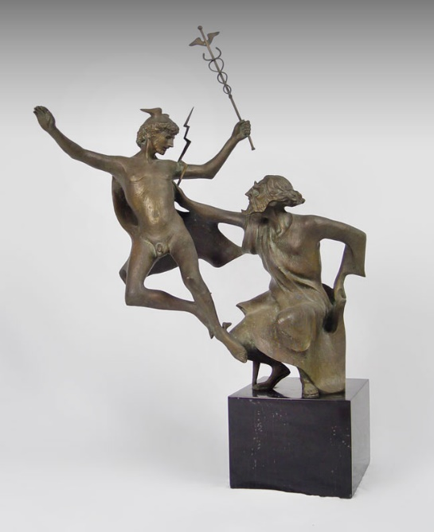
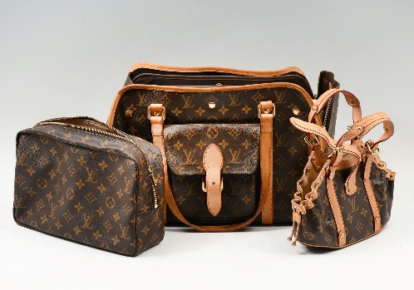
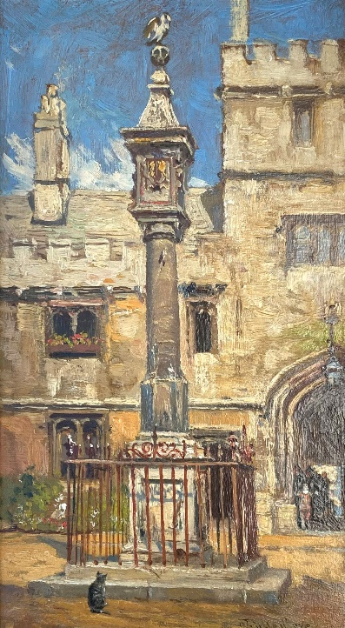
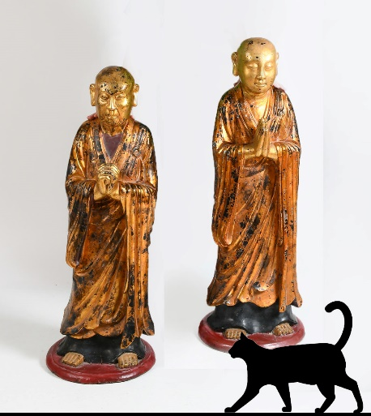
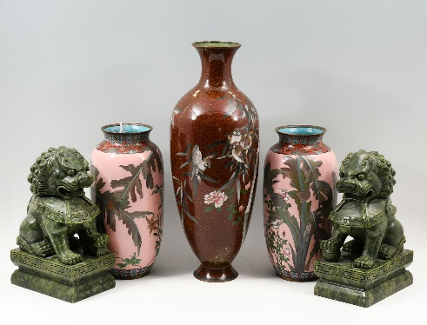
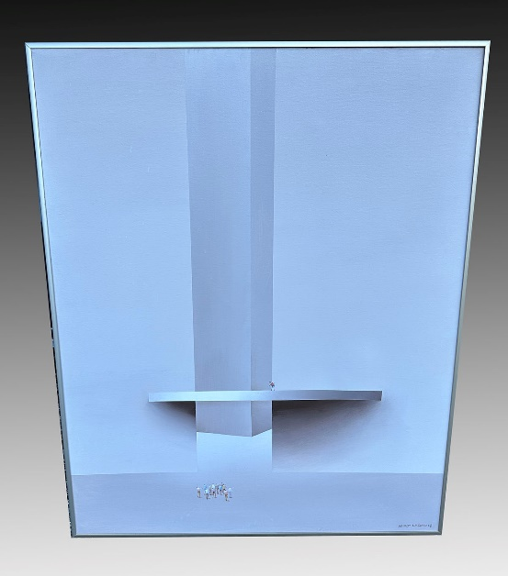
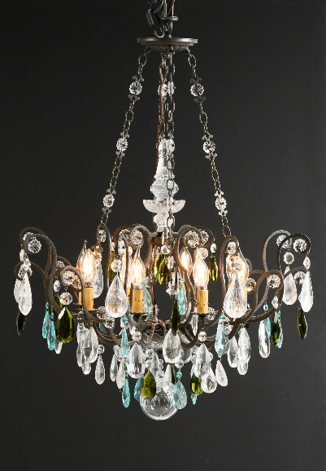
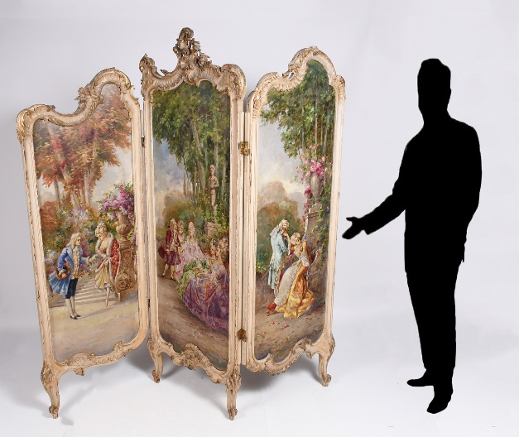
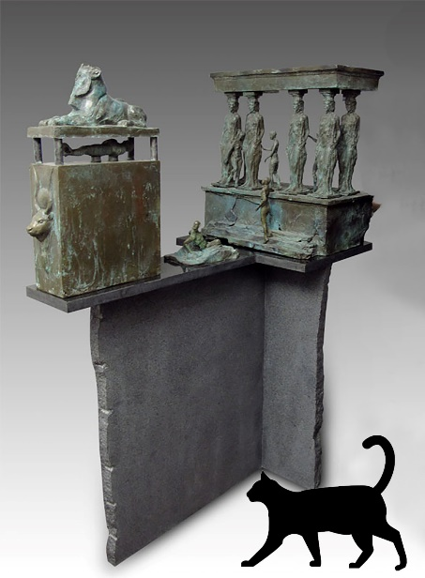
Many lifelong assemblages from astute collectors as well as our usual assortment of Museum Quality Treasure Come on D own! Prepare to be Amazed!
Carved Marble
mail@BurchardGalleries.com 727-821-1167 AU 322 AB 169
Alfred Hair Highwaymen Painting
Harry Marinsky Bronze Zeus and Mercury
Louis Vuitton Bags
John Fulleylove Corpus Christi, Oxford Painting
Large Gold Gilt Carved Buddhas
Japanese Cloisonne and Foo-Dogs
Kurt Larisch O/C
Schonbek Chandelier
Hand Painted 19th C. Screen
Large Max Demoss Bronze

